## Quick Estimation Method (QEM) for Traffic Signal Timing

The accompanying QEM_SIG Excel spreadsheet represents a computational engine for estimating signalized intersections operation. It is relying on the HCM 2010 methodology for signalized intersection analysis and the HCM QEM method, but it is also using other methodologies for computing parameters of signalized intersections (as described in the Signal Timing Manual (STM), 2008 edition). It can be used as a stand-alone application, or integrated with NeXTA.

## Methodology

The methodology of the QEM application is given by sections, and they are defined as follows (different tabs in the spreadsheet):

* Sheet 1 – input/output sheet for communication with NeXTA
* Input sheet – data input section; this is the only section where the user needs to input intersection data if the spreadsheet is used as a stand-alone application
* Phase designation – assigning phases to intersection movements, determining left turn treatment and defining ring-barrier structure
* Lane volumes – calculation of lane volumes (HCM 2010 Chapter 31)
* Phase calculation – calculation of the cycle length, green time (splits) allocations, movement capacities, V/C ratios, and Levels of Service (LOS)
* Phasing – calculate phasing data for correct export to Synchro
* Summary sheet – output sheet with calculation results

**Sheet 1** communicates with NeXTA during mesosimulation, and it reads and writes signal control data. For each intersection in the simulation, Sheet 1 reads lane configurations, turning volumes, and main movement speeds, and uses them in the calculation procedure. Then it returns data for phase designation (that includes protected/permitted phases for left turns), detector phases, effective green, capacity, V/C ratio, delay, LOS, and the complete array of phasing data. NeXTA can further use these outputs to export traffic data in the UTDF format for use with Synchro or VISSIM. When the QEM spreadsheet is used as a stand-alone application, Sheet 1 must not be deleted nor amended, since it actively communicates with other sections. It does not provide outputs in a user-friendly format, but these outputs can be used to manually export lanes/volumes/phasing/timing data to Synchro.

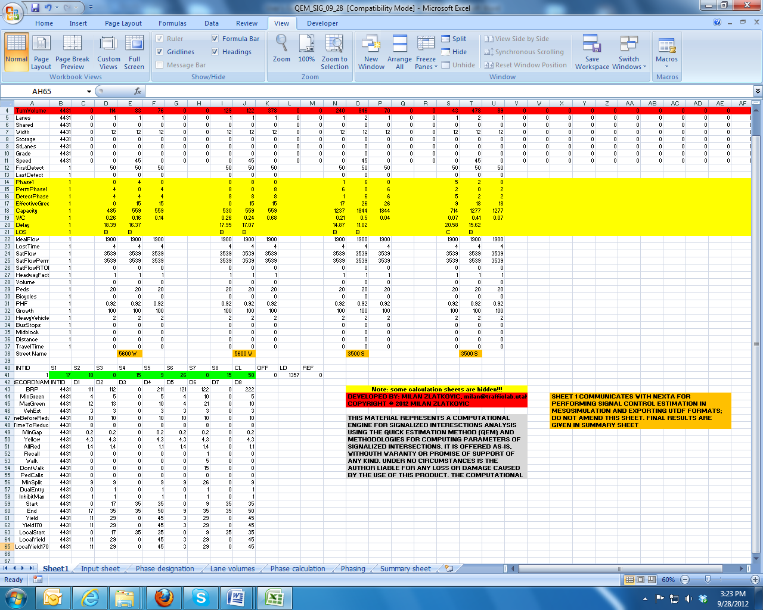

The **Input sheet** is the only section where the user is asked to enter intersection data. This sheet is important only if the QEM is used as a stand-alone application. The following inputs are needed:

* Value of time (VOT) and truck percentages – optional. This entry is used with some applications which estimate user costs for intersections. If truck percentage is not known, it can be set to 3%.
* Street names – optional.
* Intersection lane configuration – required (number of lanes for each approach and each movement).
* Turning volumes for each movement – required.
* Approach through speeds – important if these speeds are greater than 45 mph, since this is one of the requirements for protected-only left turn treatments.
* Presence of pedestrians – select option (Yes/No) from the drop-down menu for each approach. If pedestrians are present, pedestrian timing will be included in minimum splits and cycle calculation. For urban intersection, this option should generally be activated. If Sigma-X is used with the NeXTA software, this option can be set only once, and it will be the same for all intersection that NeXTA is estimating.
* Pedestrian and bicycle volumes – optional. This is an option used with some applications where pedestrian and bicycle delays and costs are estimated.
* Transit frequency – optional. It is used with some applications where transit delays are estimated.
* Manual selection of left turn treatment – if used as a stand-alone version and field data regarding left turn treatment are known, this entry allows for a manual selection of left turn treatment. If activated, this option will allow left turn treatment for each approach to be selected from the drop-down menu. The options are: Protected, Permitted, Protected + permitted, or blank. This entry will override the automatic designation of left turn treatments.   
  **Note:** if used with NeXTA, this option should be disabled. Also, if for some approaches the selection is not defined (“blank”), left turns for that approach will be assigned automatically.
* Ideal saturation flow rate – by default, this value is 1900 vphpl; needed only if the user has calibrated saturation flow rate for local conditions.
* Peak Hour Factor (PHF) – if known, it can be entered in this field. Otherwise, it can be set to the value of 1.0.
* Percentage of heavy vehicles (HGV %) – this value is entered in cell B4. If not know, can be set to 3%.
* Lost time per phase – 4s is the default value. Should be changed only if warranted by field data collection.
* Area type – CBD or Other, selected from the drop down menu.
* Minimum and maximum cycle – values used by the local agencies. The default values are 40s and 150s.
* Pedestrian speed – the default value is 3.5 fps. It is used to determine the pedestrian clearance times for signalized crossings. Can be change if field values are known.

After the input values are defined, the user should not change any other values in other sheets.

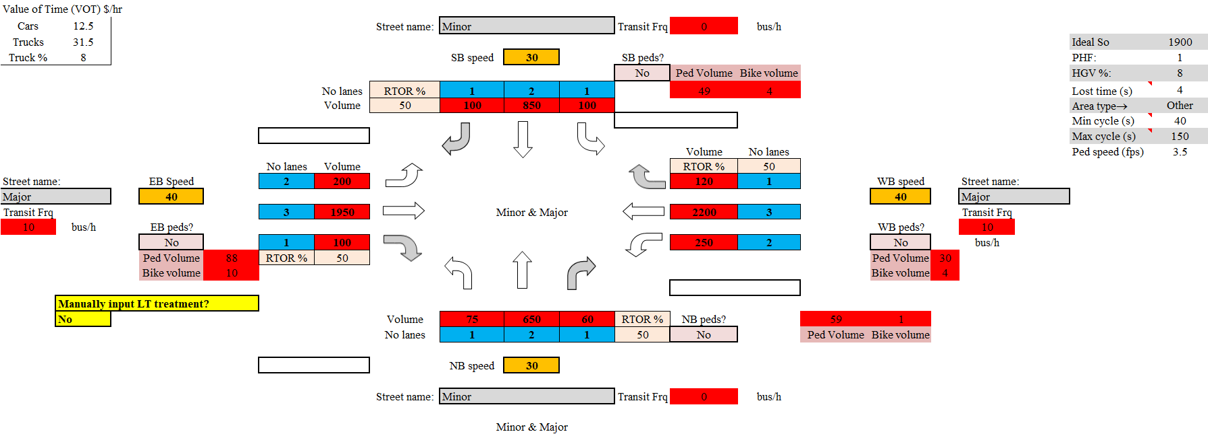

The **Phase designation** sheet determines the major street (NS or EW), defines phases for each movement, and determines the left turn treatment based on the criteria defined in the HCM and STM (Protected only, Permitted only, or Protected + permitted). If the left turn treatment is manually selected in the Input sheet, this selection will be implemented, and the automatic designation overridden. In the case of a 3-leg intersection, the left turn is treated as permitted (the through phase is shown). For phase numbering, the Utah Department of Transportation (UDOT) standard is used: if NS is the major movement, the NB through movement is phase 2; if EW is the major movement, the WB through movement is phase 2. Once the phases and left turn treatments are known, the program defines the standard dual ring-barrier structure for the given case, which is used in follow-up calculations.

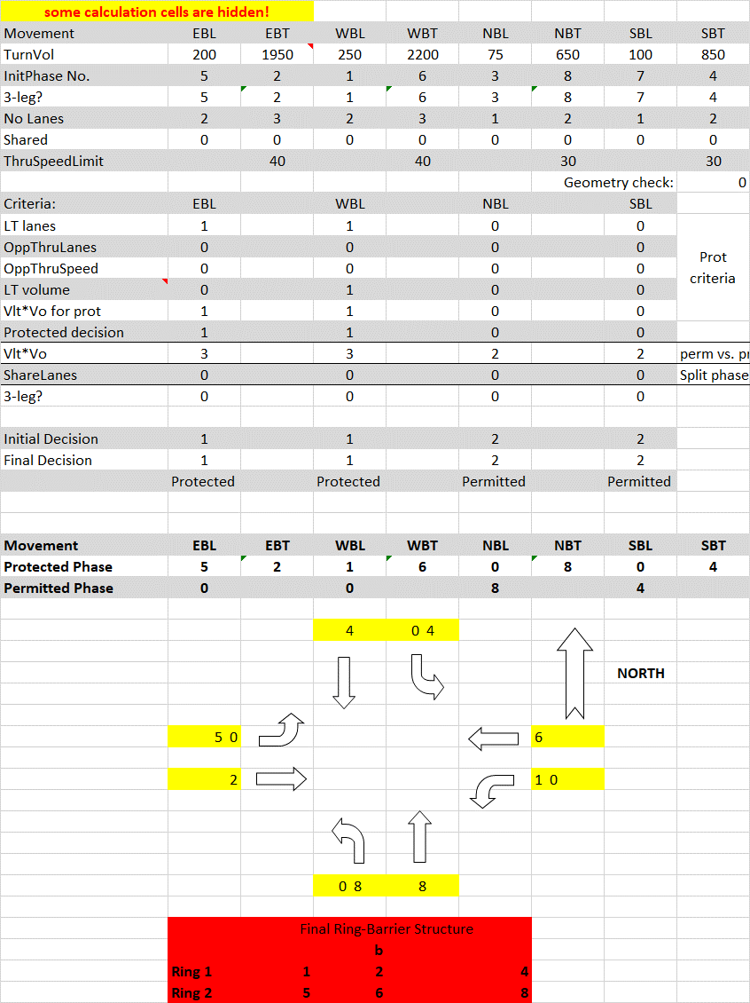

The **Lane volumes** sheet calculates critical lane volumes for each intersection approach. It follows the methodology defined in the HCM 2010, Chapter 31. The computed lane volumes are later used in cycle length calculation.

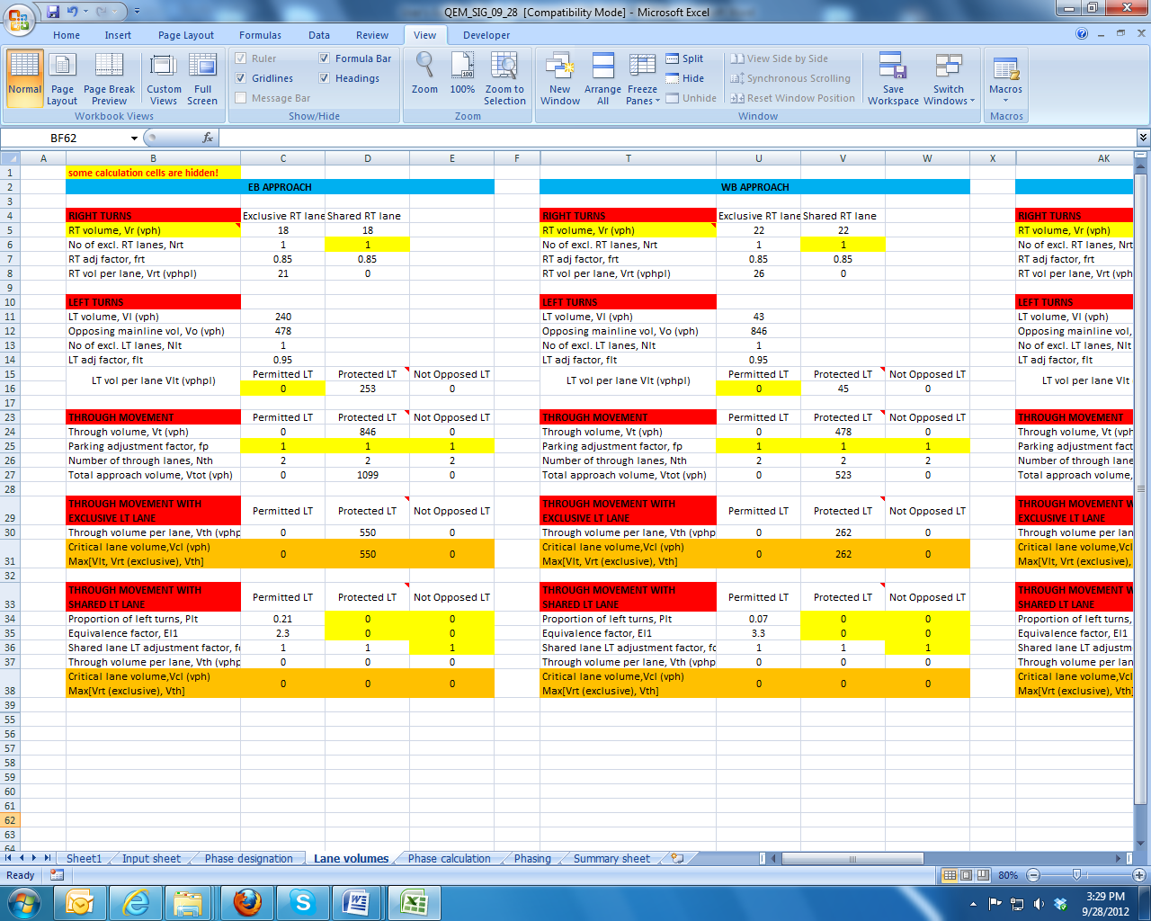

The **Phase calculation** sheet performs calculations of all signal control parameters. It is using inputs defined by the user, and outputs from the previous steps. It is using the critical movement methodology for cycle length calculations. The cycle length calculation is in this version limited to 10 second increments, in the range between 40 seconds (Cmin) and 150 seconds (Cmax). Once the cycle length is determined, the following steps are implemented in parameters calculation:

1. For the given cycle length, phasing and turning volumes, the minimum and maximum phase green times are determined.
2. The corresponding splits (green time + exchange interval) are assigned to each phase in the ring-barrier structure.
3. The splits are recalculated for each phase based on the cycle length and the critical ring split summation.
4. The splits are recalculated again for each barrier, following the critical barrier split summation. This step ensures the simultaneous barrier crossing and prevents phase conflicts.
5. The calculated splits are compared to the minimum splits (see Phasing), and are reassigned if necessary.
6. When the phase splits are know, the HCM procedure is followed to calculate movement capacities, V/C ratios, control delays and LOS.

This section goes beyond the typical QE methodology, since it gives realistic signal timing parameters common in all North American ring-barrier controllers. This is especially significant for a fast conversion process used in cross-resolution modeling (when the application is used in conjunction with NeXTA).

The cycle length can also be optimized using the Macro function. The optimization is performed in such a way to minimize the total intersection delay. It cannot be used with NeXTA.

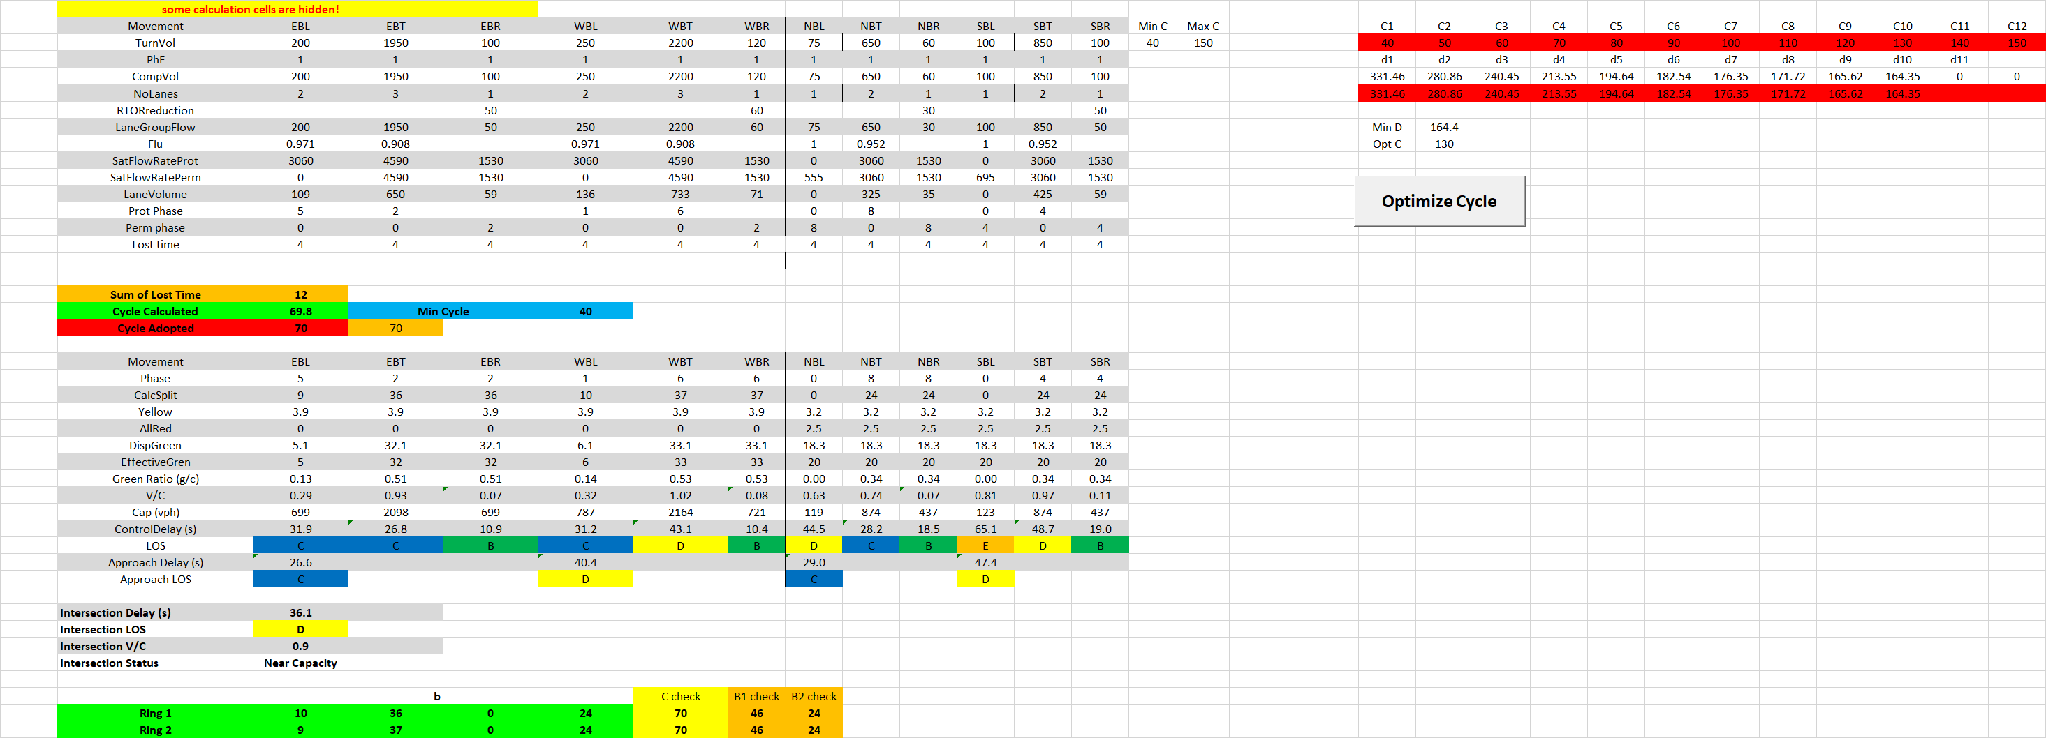

The **Phasing** sheet calculates all the phasing data required by Synchro for an error-free analysis. It is using default tables from the STM for different parameters. The parameters calculated in this sheet are:

|  |  |  |
| --- | --- | --- |
| * Minimum green | * Minimum phase recall | * Phase end time |
| * Maximum green | * Walk time | * Phase yield time |
| * Vehicle extension | * Don’t walk time | * Phase yield for type 170 controllers |
| * Time before reduce | * Pedestrian recalls | * Local start time |
| * Time to reduce | * Minimum split | * Local yield time |
| * Minimum gap | * Dual entry | * Local yield time for type 170 controllers |
| * Yellow time | * Max time call inhibition |  |
| * All red time | * Phase start time |  |

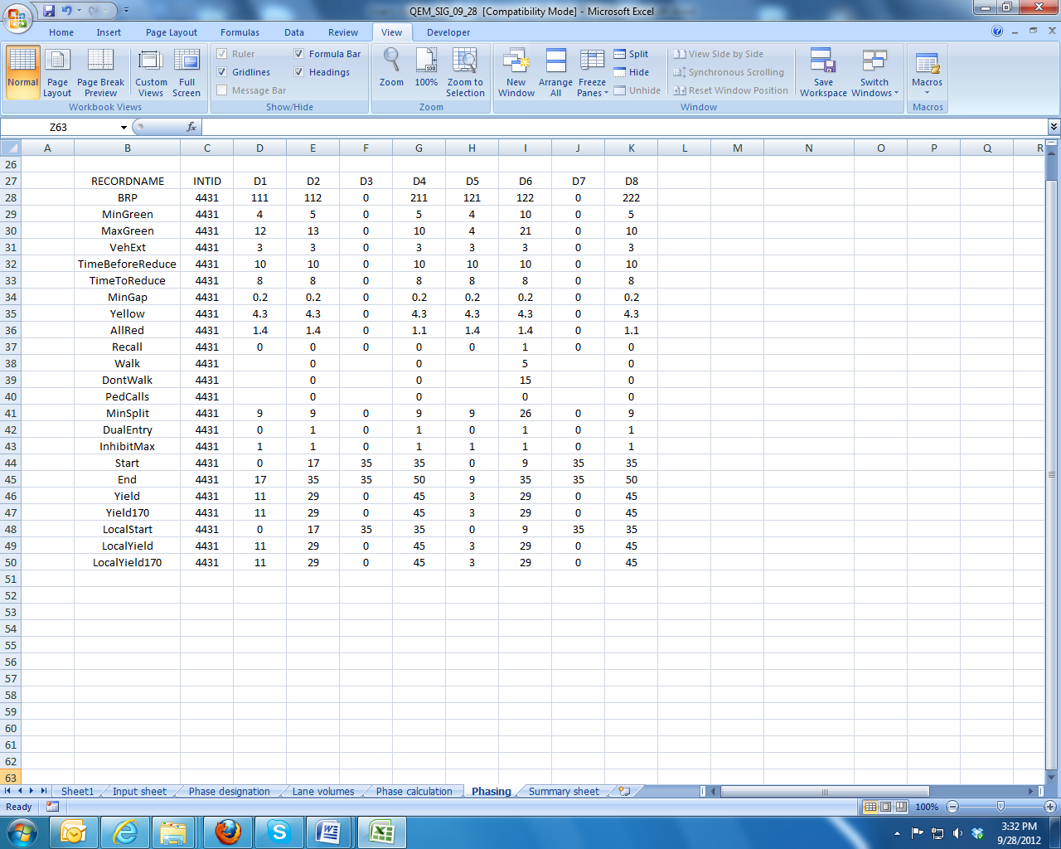

The **Summary sheet** gives all the main outputs from previous steps in is a user-friendly graphical representation. The following parameters are shown:

* Turning volumes (vph)
* Phase designations
* Split durations (s)
* Movement capacities (vph)
* V/C ratios
* Control delays (s)
* Intersection LOS

